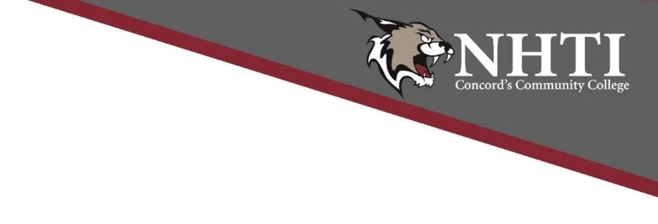
NHTI Fitness Center and Gym Hours
October 1 through November 4, 2022
Sat. Oct. 1 CLOSED
Sun. Oct. 2 5 – 10pm
Mon. – Thurs. Oct. 3 – 6 10 – 10pm
Fri. Oct. 7 10 – 4pm
Sat. Oct. 8 CLOSED
Sun. Oct. 9 5 – 10pm
Mon.- Thurs. Oct. 10 – 13 10 – 10pm
Fri. Oct. 14 10 – 4pm
Sat. Oct. 15 CLOSED
Sun. Oct. 16 5 – 10pm
Mon. -Thurs. Oct. 17 -20 10 – 10pm
Fri. Oct. 21 10 – 4pm
Sat. Oct. 22 CLOSED
Sun. Oct. 23 5 – 10pm
Mon – Thurs. Oct. 24 - 27 10 – 10pm
Fri. Oct. 28 10 – 4pm
Sat. Oct. 29 CLOSED
Sun. Oct. 30 5 – 10pm
Mon. & Tues. Oct. 31 & Nov 1 10 – 10pm
Wed. Nov 2 10 – NOON: Gym ONLY (Open House)
Wed. Nov 2 10 – 10pm: Fitness Center ONLY
Thurs. Nov 3 10 – 10pm
Fri. Nov. 4 10 – 2pm (Basketball Games)

*** All hours are subject to change.
Questions and/or concerns should be directed to Deb Smith at dsmith@ccsnh.edu.

